Topics to Study for 249

MC questions:

- Inheritance and packages

- ArrayList to Array Conversion, using, for example, public  T[] toArray(T[] arr)

- Generic classes and methods with multiple type parameters, and with bounded type parameters

- Tracing try/catch code

- Using ObjectInputStream, how do you detect end of file?

- Tracing a recursive method

- Creating objects of a public inner class, unusual notation

-----------------------------------------------

SA questions:

- Drawing UML class diagram uniting inheritance hierarchies

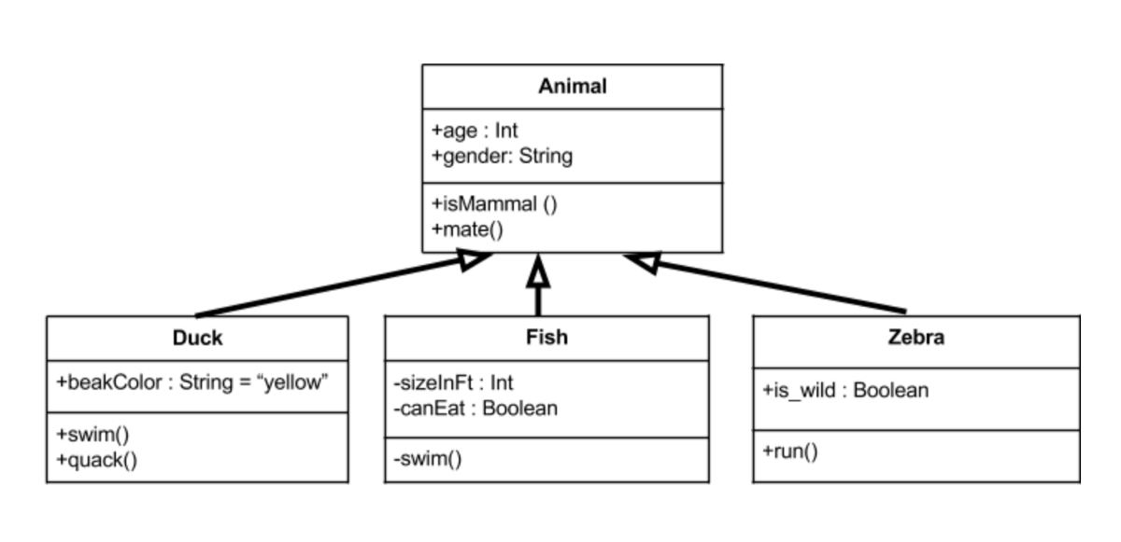

- type casting

- difference between instanceof operator and the getClass() method

- whether a given code involving an inheritance hierarchy is valid

- Tracing a recursive method

- Polymorphism, predict the output

- Exception classes

-----------------------------------------------

Programming:

 - Recursive method involving arrays

 - Recursive method not involving arrays

 - Linked list variations, traversing a list, inserting/deleting node, special cases

 - generic classes with multiple type parameters + bounded type parameters

 - text file processing

 - Exception classes

-----------------------------------------------